3 DAYS 2 NIGHTS FREE & EASY
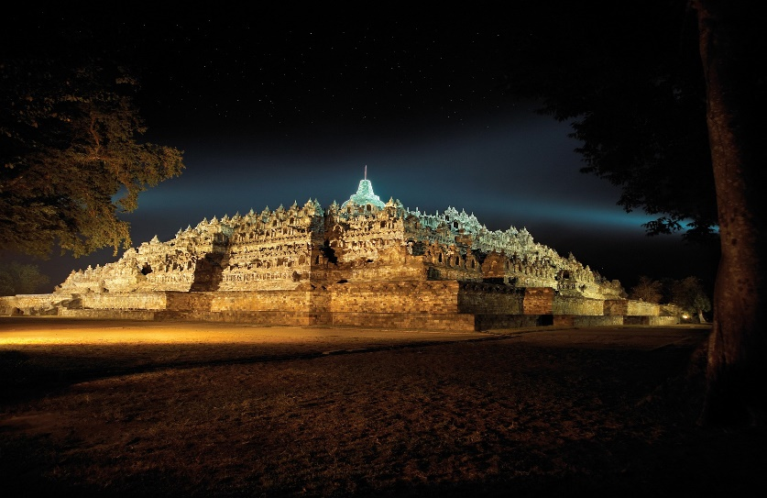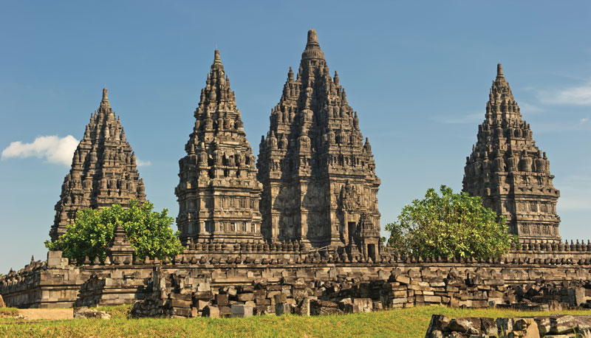

Day 1 - Arrive in jogjakarta (pick up with your driver) – hotel check in

Day 2 - Breakfast at hotel – free and easy (no tour services) (B)

Day 3 - Breakfast at hotel – complimetary transport for shooping for max 2 hours – transfer out (B)

3D2N F&E  Price per person | Twin share | Single occupancy | Child with bed | Child no bed
3*hotel cordela or hotel H boutique or similiar) | S$85 | S$165 | S$65 | S$45

Include:  - 2Nights Accommodation with breakfast  - Private transport for transfer in and out  - Complimentary shopping for 2hrs  - Driver  - Mineral water | Not Include:  - Return flight ticket and Travel insurance  - Personal expenses  - Meals (lunch and dinner)  - Everything else not stated above

Noted :
- This price will be valid only on low season until 20 March 2021
- Price valid for overseas market
- Not valid for peak season of long holiday of idul fitri 22 Mei - 7 Juni 2020, christmas and new year 21 desember 2020 - 3 Januari 2021
- No refund
- Infant below 2 years old FREE

