3 DAYS 2 NIGHTS LEMBANG BANDUNG
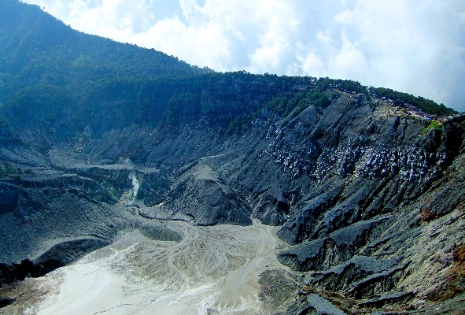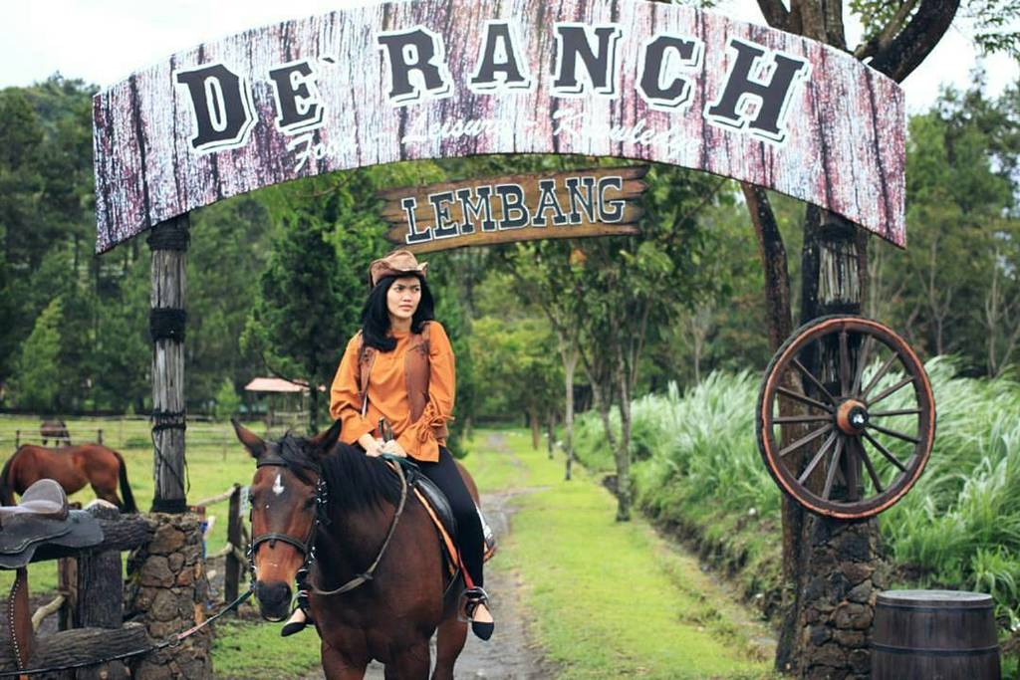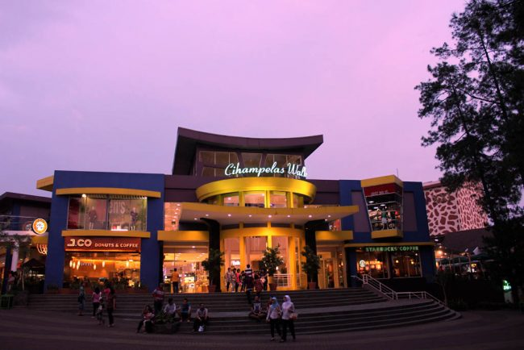

Day 1 Arrival BDO - Gunung Tangkuban Perahu - Gracia Hot Spring Lembang (L,D)
Arrival in Bandung, We will visit Gunung Tangkuban Perahu and Gracia Hot Spring Lembang

Day 2 Farm House Lembang - De Ranch Lembang - Floating Market – Shopping (B,L,D)
After breakfast, We will continue our tour with visit to the Farm House Lembang- De Ranch Lembang ,Floating Market and Shopping Skywalk Cihampelas

Day 3 Shopping Oleh-Oleh Khas Bandung - Transfer Out (B)
After breakfast and check out , our last stop for Shopping at Bandung Kartika Sari/ Prima Rasa And transfer to Airport. (Optional Tour: Alun-Alun Bandung/Gedung Asia Afrika/ Gedung Sate)

3D2N Lembang Bandung in SGD | Twin share | Single occupancy | Child with bed | Child no bed
3*Fave Braga | S$350 | S$400 | S$340 | S$280

Include:  - 2Nights accommodation with breakfast  - AC Transport in Bandung  - Meals as per itinerary  - Entrance fee as per itinerary  - Mineral water | Not Include:  - Flight ticket and travel insurance  - Personal expenses  - Everything else not stated above  - Surcharge on High Season/Peak season
Noted :
- This price will be valid only on low season until Mei 2021
- Price valid for overseas market
- Not valid for High season /peak season
- No refund
- Infant below 2 years old FREE

