4 DAYS 3 NIGHTS MEDAN -LAKE TOBA (Min 4 to go)
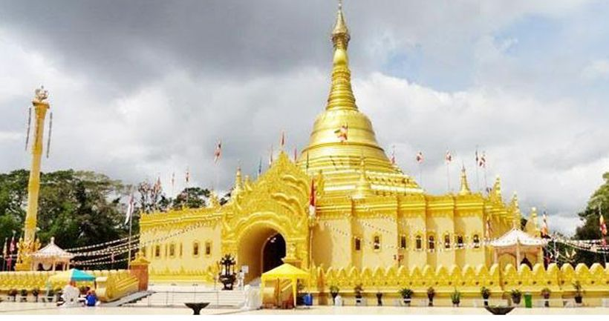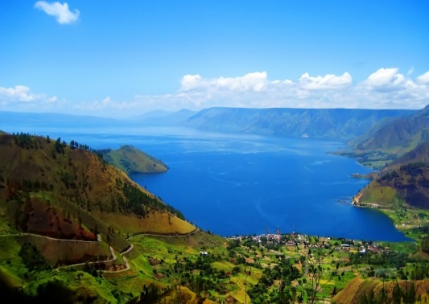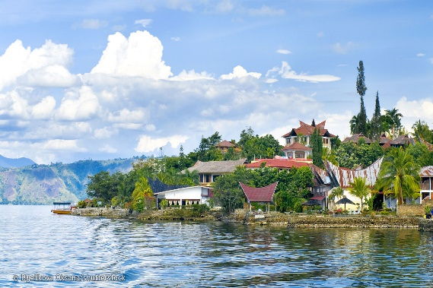
Day 1 - Kul / Medan / Brastagi (L/D)
Arrived in Medan, city tour and by transport to brastagi: visit batik house /kedai durian/ taman lumbini /pasar buah and evening walk/ nitelife in brastagi

Day 2 - Brastagi / lake toba / samosir island (B/L/D)
by transport to parapat: visit sipiso piso waterfall/simarjarunjung next to samosir island tour by boat:visit kampung ambarita to learn manortor/ batak traditional dance and evening walk /shopping souvenir/ nitelife in samosir island

Day 3 - Samosir island/ medan (B/L/D)
Morning cycling around beautiful samosir island and by boat to parapet
By transport to medan: visit ting ting, teng teng/plantations next medan city tour /shopping:visit istana shultan /kedai sulam / mesjid raya / medan mall /
merdeka walk /sun plaza, evening walk / traditional spa massage/ nitelife in medan

Day 4 - Medan/ kul (B)
Morning/city tour / shopping and transfer to airport

4D3N Package | Twin share |  | Single Occupancy | Chd with bed | Chd No bed
Hotel Green Garden, hotel Toledo,Deli -business | S$225 |  | S$295 | S$170 | S$115
Include:  - AC transportation  - Accommodation with breakfast  - Meals as per itinerary  - Sightseeing tour as stated on the program  - Local guide during tour  - Entrance fee |  | Not Include:  - Return flight ticket and Travel insurance  - Personal expenses  - Guide and driver tips  - Everything else not stated above
Remark:
- For 2 to go surcharge at S$90/person
- Valid till 20 Dec 2020
- Surcharge on peak date 20May-31 May, 19Dec-04 Jan 2021

