4 DAYS 3 NIGHTS MALANG – TSI 2 PRIGEN
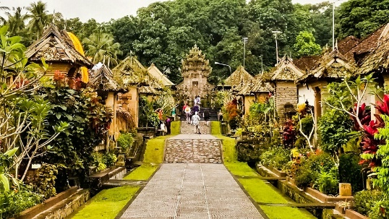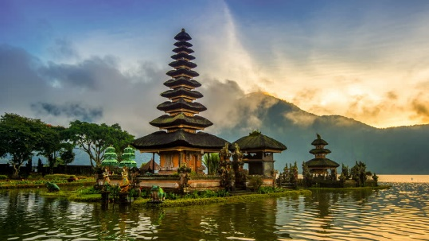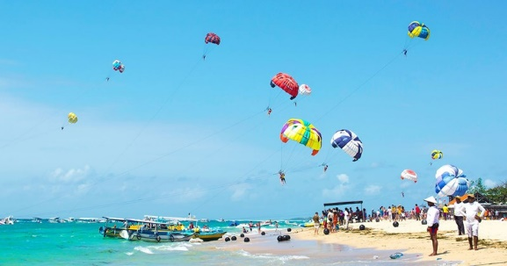

Day 1 - Arrival (-)
Arrive at Abdul Rachman Saleh Airport → Meet with driver and transfer to hotel

Day 2 - Malang City Tour (B)
Breakfast at hotel → Proceed to visit Mpu Purwa Museum and Panji Museum → Continue with Malang City Tour (Idjen Boulevard, Malang City Square, City Hall and Souvenir Shop) → Then visit Kajoetangan Heritage Village and Night Paradise → Transfer back to hotel

Day 3 - Taman Safari Indonesia 2 Prigen (B)
Breakfast at hotel → Proceed to Taman Safari 2 Prigen with Unlimited Elephant Ticket where you can have fun in the zoo → Transfer back to hotel

Day 4 - Departure (B)
Breakfast at hotel → Transfer to Abdul Rachman Saleh Airport

Valid till 31 Mar 2021
4D3N Package per person | Twin share | Single occupancy |  | Chd with bed | Chd No bed
eL Grande Hotel Malang | S$395 | S$465 |  | S$298 | S$198
Include:  - AC transportation (driver, gasoline, all fees)  - Accommodation with breakfast  - Return airport transfer  - Sightseeing tour as stated on the program  - Local guide during tour  - Entrance fee & donation  - Snack box and mineral water |  |  | Not Include:  - Return flight ticket and Travel insurance  - Personal expenses  - Guide and driver tips  - Everything else not stated above

