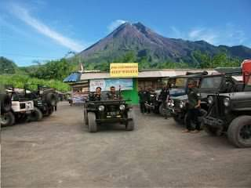
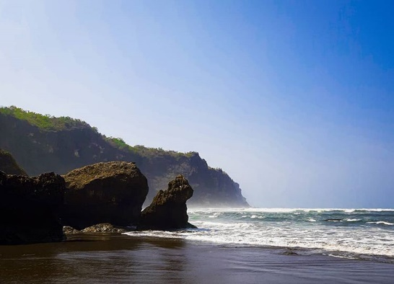
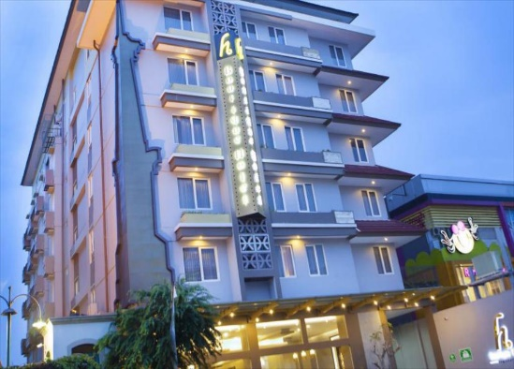
3 DAYS 2 NIGHTS JOGJA FULLBOARD TOUR

Day 1 - Arrive in Jogja – Parangtritis for Sunset (L, D)
Pick Up service at jogja Airport or hotel. Pick up/Meet and greet with your driver/guide - lunch at local resto – Kota gede
for silver craft manufacture and collection - chocolate tugu factory and leather craft gallery – dune sand/gumuk pasir and
parangtritis beach for sunset - dinner at local resto - check in hotel and free program

Day 2 - Merapi Tour – Borobudur Temple (B,L,D)
Breakfast at hotel – merapi view with jeep – lunch at local resto – borobudur temple - dinner at local resto – if still have a
time,then...free program at jalan malioboro – back to hotel

Day 3 - C/O hotel - Transfer out to Airport (B)
Breakfast at hotel and C/O- pick up at your hotel – shooping at bakpia patuk for jogja local snack - Transfer out to Jogja
International Airpotrt your return flight

3D2N Jogja Fullboard tour (price per person) | Twin share | Child with bed | Child no bed
3*hotel cordela or hotel H boutique or similiar | S$215 | S$160 | S$110

Include:  - Private transport air cond  - 2Nights Accommodation with breakfast  - Meals as per itinerary/program  - Jeep 4x4 for merapi volcano tour (1 jeep has max capacity up to 4 pax)  - Driver cum guide  - Mineral water on tour | Not Include:  - Return flight ticket and Travel insurance  - Personal expenses  - Everything else not stated above
Noted :
- This price will be valid only on low season until 20 March 2021
- Price valid for overseas market
- Not valid for peak season of long holiday of idul fitri 22 Mei - 7 Juni 2020, christmas and new year 21 desember 2020 - 3 Januari 2021
- No refund
- Infant below 2years old FREE

