3 DAYS 2 NIGHTS SILANGIT -DANAU TOBA-SAMOSIR ISLAND
(Min 4 to Go)
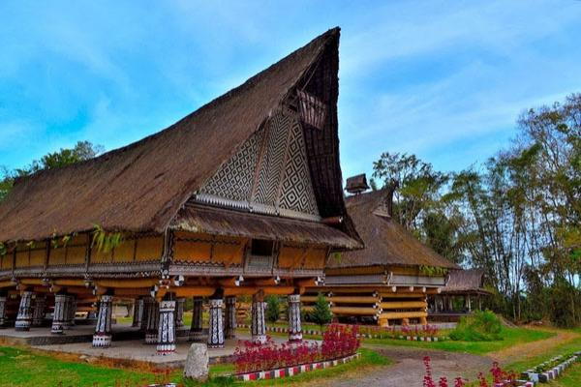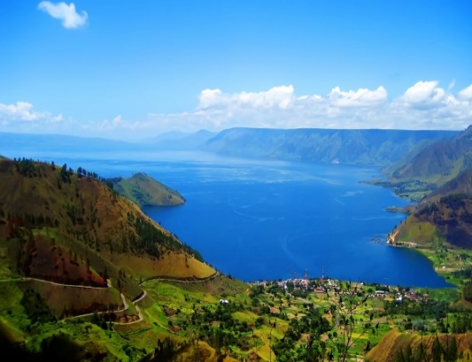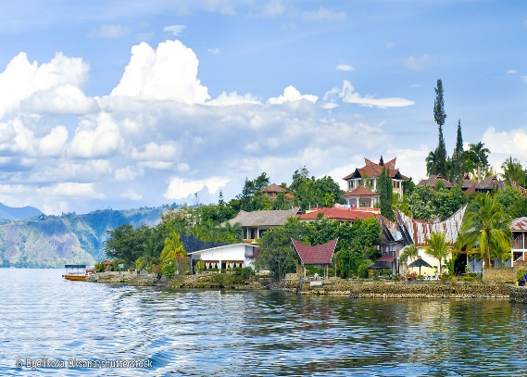

Day 1 - kul / silangit / samosir island (L/D)
Visit hutaginjang for beautiful scenery of southern tip of lake toba,balige, by boat to samosir island and cycling - bersepeda around beautiful samosir island, evening walk / shopping souvenir / nitelife in samosir island

Day 2 - samosir island / parapat – balige (B/L/D)
samosir island tour by boat : visit kampung ambarita to learn manortor - traditional batak dance /
to see traditional batak house and visit kampung tomok to see batak kings tombs / to buy souvenirs, next visit rumah sukarno / pasar souvenir / monkey forest and evening walk / shopping souvenir / nitelife in parapat – balige

Day 3 - silangit / kul (B)
Morning city tour / shopping and transfer to airport

3D2N Package | Twin share | Single Occupancy | Chd with bed | Chd No bed
Hotel Toledo& Noah | S$195 | S$245 | S$145 | S$100

Include:  - AC transportation  - Accommodation with breakfast  - Meals as per itinerary  - Sightseeing tour as stated on the program  - Local guide during tour  - Entrance fee | Not Include:  - Return flight ticket and Travel insurance  - Personal expenses  - Guide and driver tips  - Everything else not stated above
Remark:
- For 2 to go surcharge at S$70/person
- Valid till 20 Dec 2020
- Surcharge on peak date 20May-31 May, 19Dec-04 Jan 2021

